# The Big Task Wheel

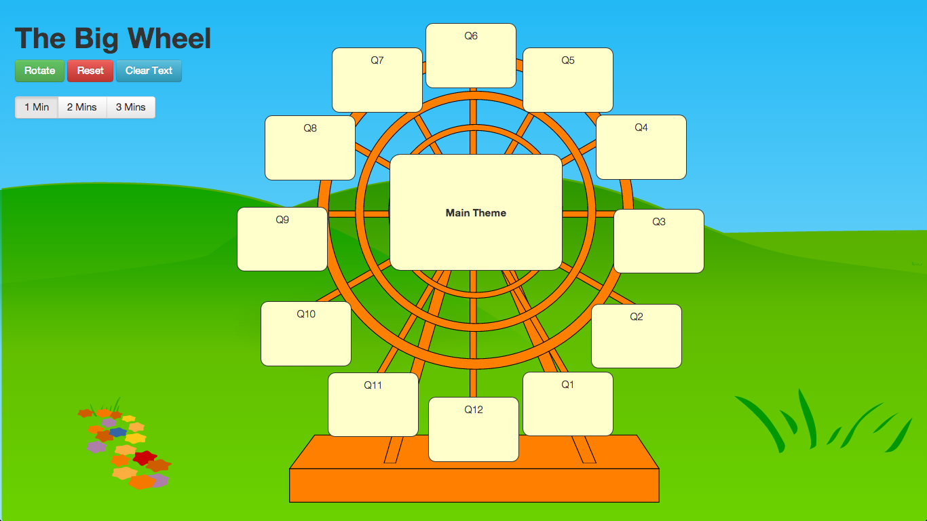

Website: [**tinyurl.com/taskwheel**](http://tinyurl.com/taskwheel)

## Overview:

The Big Task Wheel allows you to set **up to** 12 separate tasks or questions for students to complete. Each task or question has a different amount of time to complete in multiples of 1, 2 or 3 minutes. Tasks or questions should be of increasing difficulty to allow for differentiation within your class.

When a teacher starts the activity, the wheel starts to rotate. The aim is for pupils to complete a task before it reaches the bottom and turns red. Each time a task turns red a bell sound will be played.

## **Instructions**:

### Editing the text

* Each of the boxes can be edited, click on a box to change the text.  
  If you don’t need text in every box, you can just delete the text from an individual box. This allows varying time between tasks e.g. 1 minute between tasks 1 to 3 then no task 4 so 2 minutes to task 5.
* If there is not enough space to fit the text that you would like, you can decrease the font size 
* If you would like to start with a blank canvas you can press  to empty all the boxes.
* Once you have entered the text you would like to use, press  and copy the long URL that is displayed. You can save that in an e-mail, a text file or in the slide notes of your presentation.

### Timing

* Set how much time you want to allow between each task.   
  By default it is set to 1 minute.

### Starting the Activity

* Press  to start the wheel, if you need to you can pause the wheel by pressing 
* Pressing  will move the wheel back to the starting position, the text will not be lost.

If you would like to show it in full screen press F11 on your keyboard

To zoom in you can press **Ctrl** and **+**To zoom out you can press **Ctrl** and **-**

The text will be saved in your browser history (cookies) so it doesn’t matter if you close the website and come back to it.